**W04 Final Project: Proposal**

**Overview of the idea. Why are we doing this? What is the problem we are trying to solve?**

There are times when you are thinking about a movie, but you just can't remember its name. We want to help people find movies with just a few clicks and provide them with useful information from movies.

**Who is the audience?**

Everyone looking for movies, trying to remember the title of a movie, or just looking for more information about the movies they love. They could be friends planning a movie night, coworkers suggesting movies to their partners, or anyone who doesn't know what to watch. Finally, we target people of all ages and backgrounds.

**Major functions of the application. What will it do?**

The main function of the application would be searching for movies. You type the name of the movie or part of the title, and the page will render a list of movies with some basic information. Then if you click on one movie from the list, you are taken to a page where you can find more detailed information about the movie.

Some extra functionality that we are still thinking we could add is to show movies from last year or the current year on the home page, for people looking for current movies. Finally, a personal list where you can save movies that you are interested in; You could also mark your movies watched.

**Wireframes of the major views (Mobile and desktop)**

# Desktop - Home

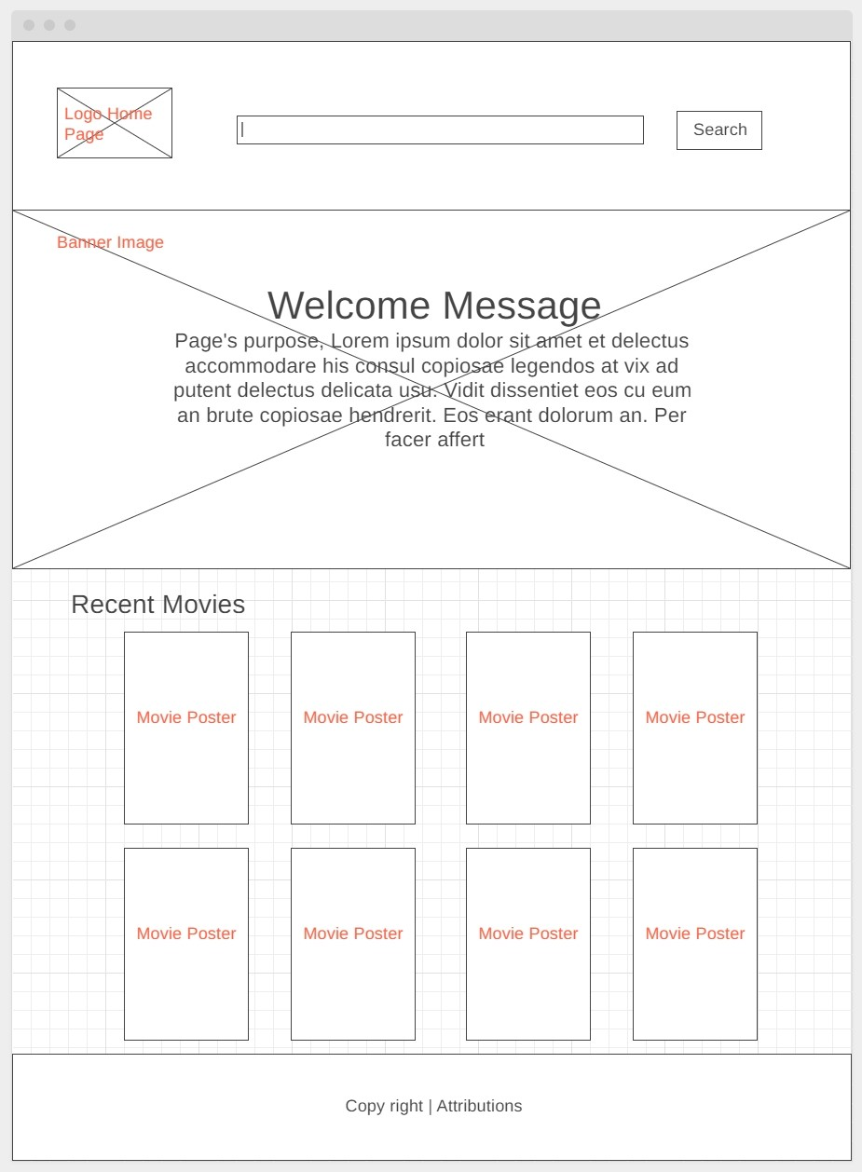

# Desktop – Search

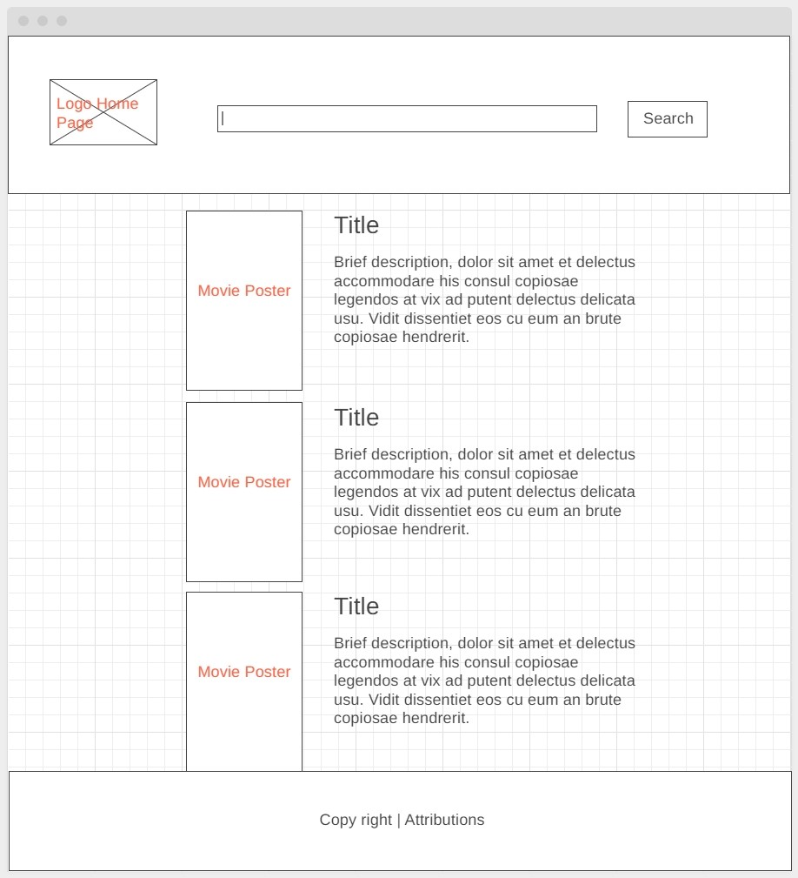

# Desktop – Movie Details

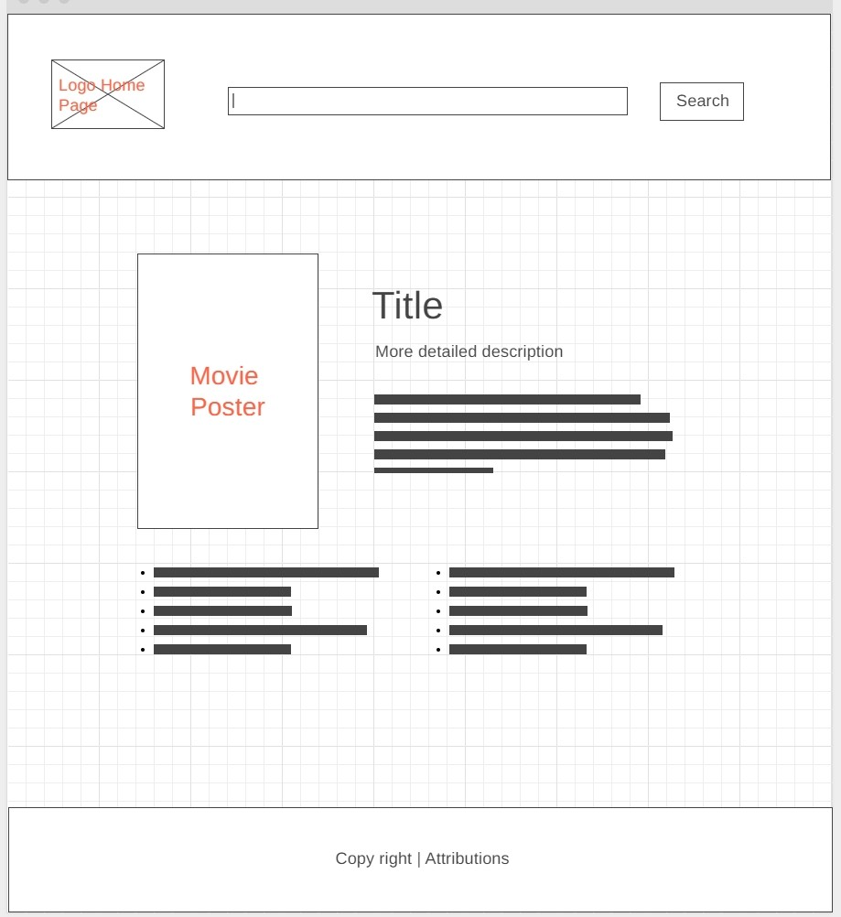

# Mobile – Home / Search

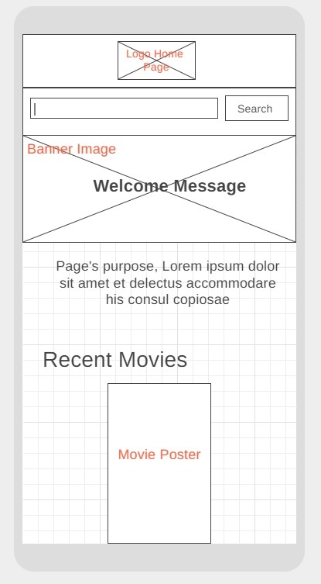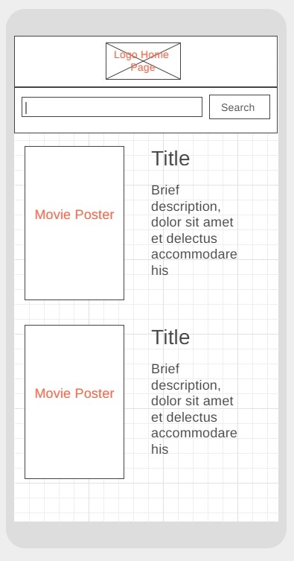

# Mobile – Movie Details

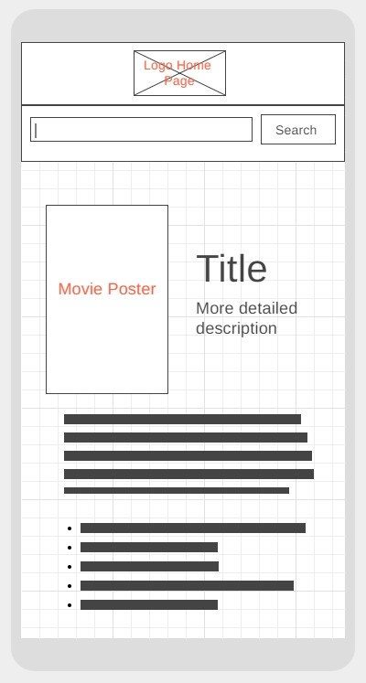

# Data sources

We will use the OMDb API: [omdbapi.com](https://www.omdbapi.com/)

Optionally, we will use the localStorage API.

# Initial Module list

* ExternalDataHandler / It will get and prepare data to pass it to the display modules.
* DisplayList / It will prepare basic movies data to be displayed in the DOM as a list.
* DisplaySingle / It will prepare detailed data to be displayed in the DOM from a single movie.
* generalPurpose / Not a module, but it will include useful functions for all modules. If your function would work on more than one module, it should be here so you can export it.
* userList / It will add movies selected by the user to his own list and handle different aspects of the list. (This module would an extra if we have enough time)

**Colors/Typography/specific Element styling**

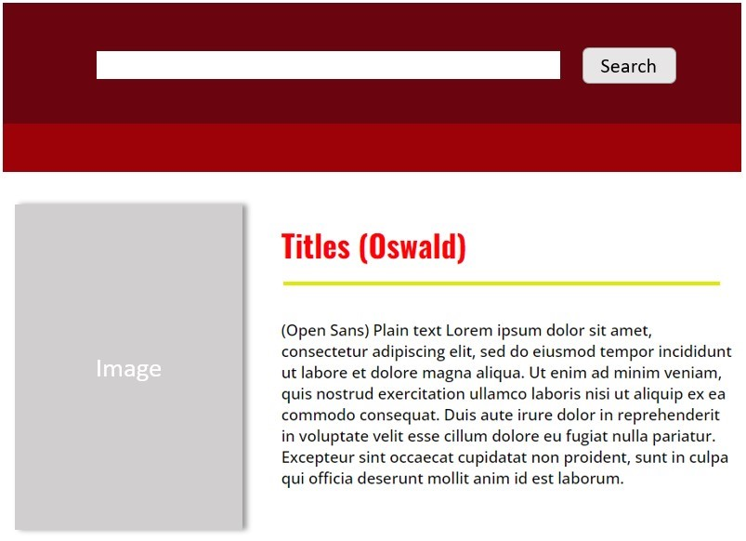

We will use “Oswald” for headers, and “Open Sans” for paragraphs (From Google Fonts).

Color palette:

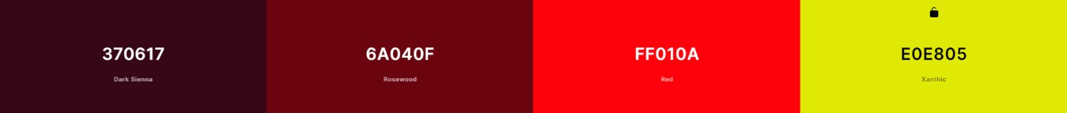

**Schedule / Mile markers along the way to help us stay on target.**

W05 First Half -Completed basic HTML for home page, including Header and Footer templates to share across pages.

W05 Second Half -Completed HTML for the rest of the pages and CSS for all pages. (We could use place holders to work on styling before we add dynamically generated lists)

W06 First Half -Create and test ExternalDataHandler. We should handle the search input and clicking on movie. We will test it just by using console.log, making sure that we get the information we need with Input or eventListener.

W06 Second Half -Start creating DisplayList / DisplaySingle. Once the external data handler is completed, we can start creating these modules at the same time. If convenient, we create functions in generalPurpose for everyone to use.

W07 First Half -Continue and finish DisplayList / Display single. Start and finish Testing. If convenient, we create functions in generalPurpose for everyone to use.

Extra tasks (If we have enough time)

W07 Second Half -Create userList using localStorage / Tests and final touches.

# Link to a Trello board with all the tasks we can think of at this point defined as cards

https://trello.com/b/tjgUFuMv/movie-finder-app